**USING RAPTOR – COUNT AND PRINT VOWELS IN GIVEN WORD**

**A.V Bhargava(191911110)**

**FLOWCHART**

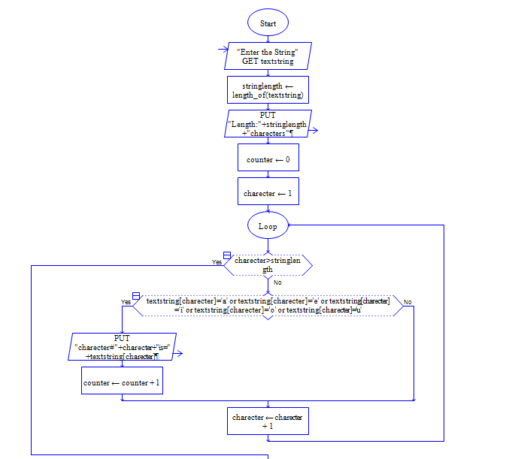



**OUTPUT**

INPUT IS vishnuvardhan

